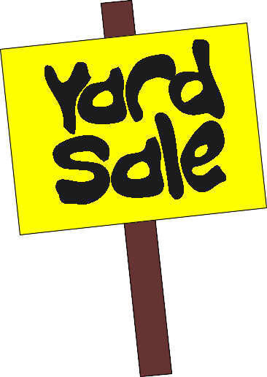
Clinton’s Town Wide Yard-Sale: Seller Form!
When: Saturday, June 10th, 2017 (rain date June 17t^{h})
Time: 8:30 am – 1:00 pm
Where: Central Park/Resident homes
**Register by Friday June 2nd, 2017
The benefits of participating:
- The Parks and Recreation Department will list your sale on a master map that will be distributed to buyers so that your sale is more visible
- You will receive a flag to display to help attract customers to your sale
 | Class | Cost
 | Booth at Central Park (each booth space is 20’ by 10’) | $15
 | Home Sale | $10
 | Discover Clinton Sidewalk Sales Day  Set-up booth on High Street. Checks to be made out to Uptown  What will you be selling?______________ | $15

- Check this box if you a Central Park Seller and would like to rent table/chair from Callahan’s Rental
(Tables are $7.00 a piece, chairs are $2.00 a piece; this is paid directly to Callahan Rental)

_______________________________________________________________________
Name of seller

______________________________________________________________________________
Address of seller

______________________________ _________________________________
Home phone Cell phone

___________________________________________________________
Email address

For those sellers participating in the sale at central park, seller is responsible for set-up, clean-up and merchandise removal after the sale; if sale items are left after the sale the seller will be charged a $25.00 cleaning fee. Seller is responsible for handling all sale transactions. Checks can be made out to the Town of Clinton if you need a bigger plot of land please sign up for 2 booths at the Central Park Location.

_____________________________________________ ________________
Signature Date
Office use only
Form of Payment: ◻Cash ◻Credit ◻Check #_______ Amount Received: $_______ Date: ________
Was Yard Flag Given? ◻Yes ◻No By: _________ Date: ________

